All methods and model implementations code with input and output

1.
Kbann
CODE:
import numpy as np
import pandas as pd
from itertools import product

from sklearn.model_selection import StratifiedKFold, cross_val_score
from sklearn.preprocessing import StandardScaler
from sklearn.feature_selection import SelectKBest, chi2
from sklearn.neural_network import MLPClassifier
data = []
with open("splice.data") as f:
for line in f:
parts = line.strip().split(",")
label = parts[0].strip()
seq = parts[2].replace(" ", "")
data.append([label, seq])
df = pd.DataFrame(data, columns=["label","sequence"])
# remove non-splice examples
df = df[df["label"] != "N"]
# encode labels
df["label"] = df["label"].map({"EI":1, "IE":0})
X_seq = df["sequence"].values
y = df["label"].values

mapping = {
"A":[1,0,0,0],
"C":[0,1,0,0],
"G":[0,0,1,0],
"T":[0,0,0,1]
}

def encode_sequence(seq):
vec = []
for base in seq:
vec.extend(mapping.get(base,[0,0,0,0]))
return vec

onehot_X = np.array([encode_sequence(s) for s in X_seq])

# =========================
# 3 RULE BASED FEATURES
# =========================

def rule_features(seq):

donor = 1 if seq[30:32] == "GT" else 0
acceptor = 1 if seq[28:30] == "AG" else 0

A = seq.count("A")
C = seq.count("C")
G = seq.count("G")
T = seq.count("T")

return [donor, acceptor, A, C, G, T]

rule_X = np.array([rule_features(s) for s in X_seq])

# =========================
# 4 KMER FEATURES
# =========================

def kmer_features(seq, k=2):

kmers = [''.join(p) for p in product("ACGT", repeat=k)]
features = []

for kmer in kmers:
features.append(seq.count(kmer))

return features

kmer_X = np.array([kmer_features(s,2) for s in X_seq])

# =========================
# 5 POSITION FEATURES
# =========================

def position_features(seq):

window = seq[27:33] # region near splice junction
vec = []

for base in window:
vec.extend(mapping.get(base,[0,0,0,0]))

return vec

pos_X = np.array([position_features(s) for s in X_seq])

# =========================
# 6 COMBINE FEATURES
# =========================

X = np.concatenate((onehot_X, rule_X, kmer_X, pos_X), axis=1)

# =========================
# 7 FEATURE SCALING
# =========================

scaler = StandardScaler()
X = scaler.fit_transform(X)

# =========================
# 8 FEATURE SELECTION
# =========================

selector = SelectKBest(chi2, k=200)
X = selector.fit_transform(abs(X), y)

# =========================
# 9 KBANN MODEL
# =========================

kbann_model = MLPClassifier(
hidden_layer_sizes=(256,128,64),
activation='relu',
solver='adam',
learning_rate_init=0.001,
max_iter=10000,
early_stopping=True
)

# =========================
# 10 CROSS VALIDATION
# =========================

cv = StratifiedKFold(n_splits=10, shuffle=True, random_state=42)

kbann_scores = cross_val_score(kbann_model, X, y, cv=cv)

# =========================
# 11 RESULTS
# =========================

print("KBANN Neural Network Accuracy:", kbann_scores.mean())

OUTPUT:
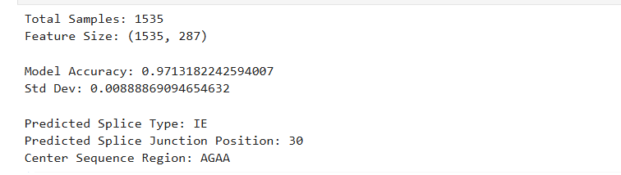

2.
LOGISTIC REGRESSION
CODE:
import pandas as pd
import numpy as np
from sklearn.model_selection import train_test_split
from sklearn.linear_model import LogisticRegression
from sklearn.preprocessing import LabelEncoder
from sklearn.metrics import accuracy_score
data = pd.read_csv("splice.data", header=None)

data.columns = ["class", "id", "sequence"]

data.head()
data['sequence'] = data['sequence'].str.replace(" ", "")
data = data.drop("id", axis=1)

data.head()
import numpy as np

mapping = {
'A':[1,0,0,0],
'C':[0,1,0,0],
'G':[0,0,1,0],
'T':[0,0,0,1],
'N':[0,0,0,0]
}

def encode_seq(seq):
encoded = []

for char in seq:
encoded.extend(mapping.get(char,[0,0,0,0]))

return encoded

X = data['sequence'].apply(encode_seq)
X = np.array(X.tolist())
from sklearn.preprocessing import LabelEncoder

le = LabelEncoder()
y = le.fit_transform(data['class'])
from sklearn.model_selection import train_test_split
from sklearn.linear_model import LogisticRegression
from sklearn.metrics import accuracy_score

X_train, X_test, y_train, y_test = train_test_split(
X, y, test_size=0.2, random_state=42
)

for i in [500, 1000, 2000, 5000, 10000]:

model = LogisticRegression(max_iter=i)

model.fit(X_train, y_train)

y_pred = model.predict(X_test)

acc = accuracy_score(y_test, y_pred)

print("max_iter:", i, "Accuracy:", acc)
from sklearn.metrics import classification_report

print(classification_report(y_test, y_pred))
from sklearn.model_selection import cross_val_score

scores = cross_val_score(model, X, y, cv=10)

print("Cross Validation Accuracy:", scores.mean())
OUTPUT:
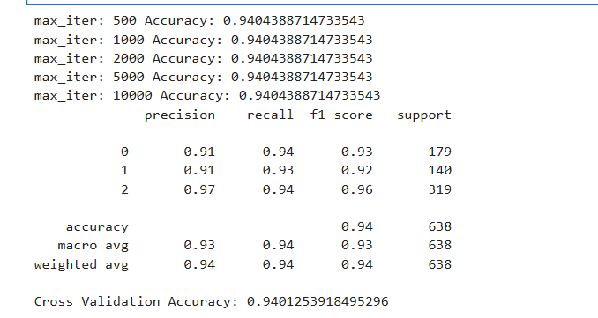

3. CNN
CODE:
import os
import json
import numpy as np
import pandas as pd

from tensorflow.keras.models import Sequential
from tensorflow.keras.layers import Conv1D, MaxPooling1D, Flatten, Dense
from tensorflow.keras.utils import to_categorical
from sklearn.model_selection import train_test_split
from sklearn.metrics import accuracy_score, precision_score, recall_score, f1_score, confusion_matrix

from services.data_service import load_data
from services.preprocess import encode_sequence

# 🔹 Ensure models folder exists
os.makedirs("models", exist_ok=True)

# 🔹 Load dataset
df = load_data()

X = []
y = []

label_map = {
"EI": 0,
"IE": 1,
"N": 2
}

# 🔹 Prepare data
for _, row in df.iterrows():
seq = row["sequence"]

encoded = encode_sequence(seq)

# reshape into (sequence_length, 4)
encoded = np.array(encoded).reshape(-1, 4)

X.append(encoded)
y.append(label_map[row["label"]])

X = np.array(X)
y = np.array(y)

# 🔹 One-hot labels
y_cat = to_categorical(y, num_classes=3)

# 🔹 Train-test split
X_train, X_test, y_train, y_test = train_test_split(
X, y_cat, test_size=0.2, random_state=42
)

# 🧠 MODEL
model = Sequential([
Conv1D(filters=32, kernel_size=3, activation="relu", input_shape=(X.shape[1], 4)),
MaxPooling1D(pool_size=2),

Conv1D(filters=64, kernel_size=3, activation="relu"),
MaxPooling1D(pool_size=2),

Flatten(),
Dense(64, activation="relu"),
Dense(3, activation="softmax")
])

model.compile(
optimizer="adam",
loss="categorical_crossentropy",
metrics=["accuracy"]
)

# 🔹 Train
history = model.fit(
X_train,
y_train,
epochs=5,
batch_size=32,
validation_split=0.1,
verbose=1
)

# 🔹 Evaluate
y_pred_probs = model.predict(X_test)
y_pred = np.argmax(y_pred_probs, axis=1)
y_true = np.argmax(y_test, axis=1)

accuracy = accuracy_score(y_true, y_pred)
precision = precision_score(y_true, y_pred, average="weighted")
recall = recall_score(y_true, y_pred, average="weighted")
f1 = f1_score(y_true, y_pred, average="weighted")
cm = confusion_matrix(y_true, y_pred)

print("\n===== DL MODEL METRICS =====")
print("Accuracy:", accuracy)
print("Precision:", precision)
print("Recall:", recall)
print("F1 Score:", f1)
print("Confusion Matrix:\n", cm)

# 🔹 Save model
model.save("models/dl_model.h5")
print("\nDL model saved → models/dl_model.h5")

# 🔹 Save metrics
metrics = {
"accuracy": float(accuracy),
"precision": float(precision),
"recall": float(recall),
"f1_score": float(f1),
"confusion_matrix": cm.tolist()
}

with open("models/dl_metrics.json", "w") as f:
json.dump(metrics, f)

print("Metrics saved → models/dl_metrics.json")

OUTPUT:
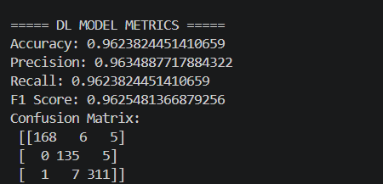
4. NAÏVE BAYES
CODE:
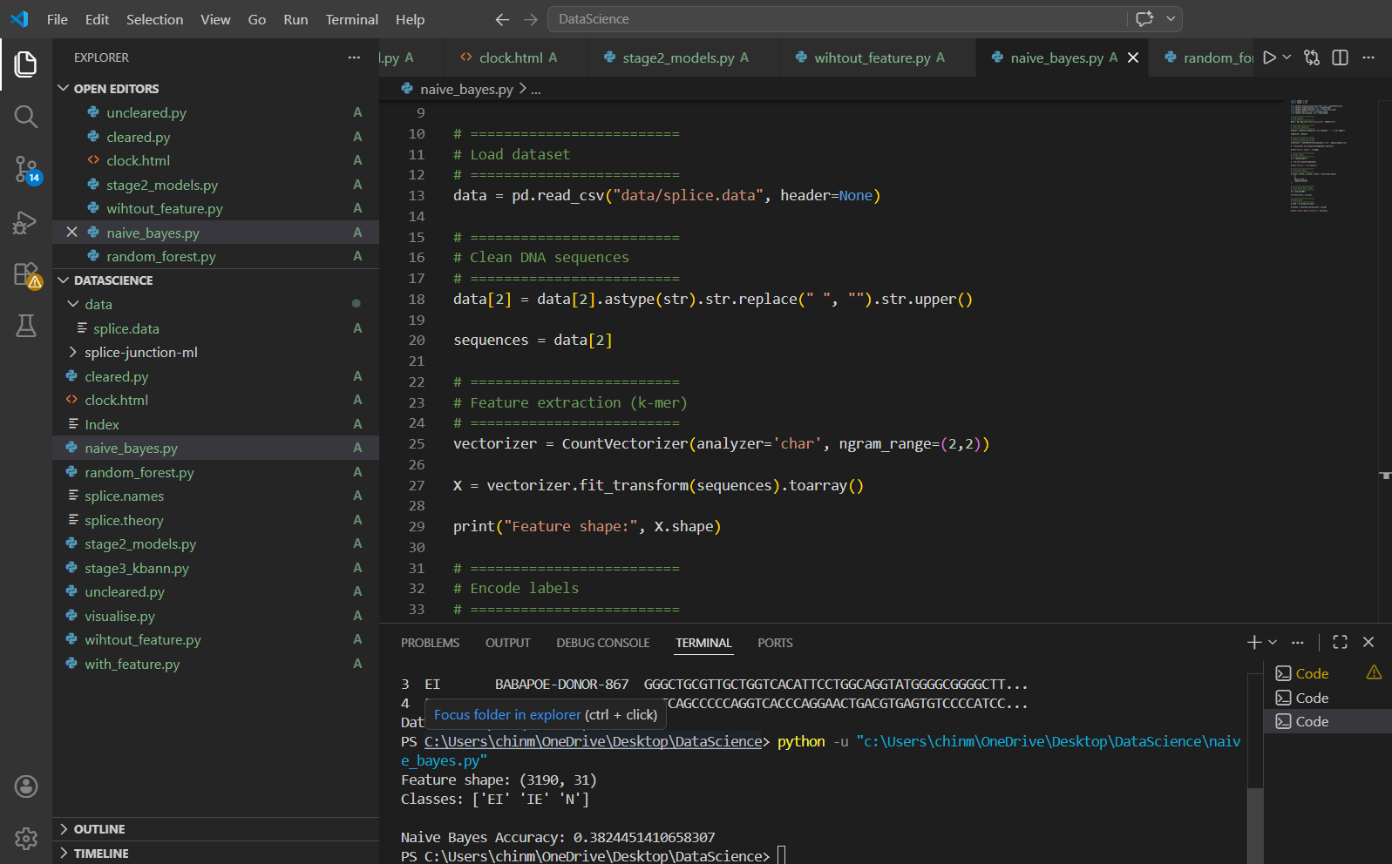
OUTPUT:
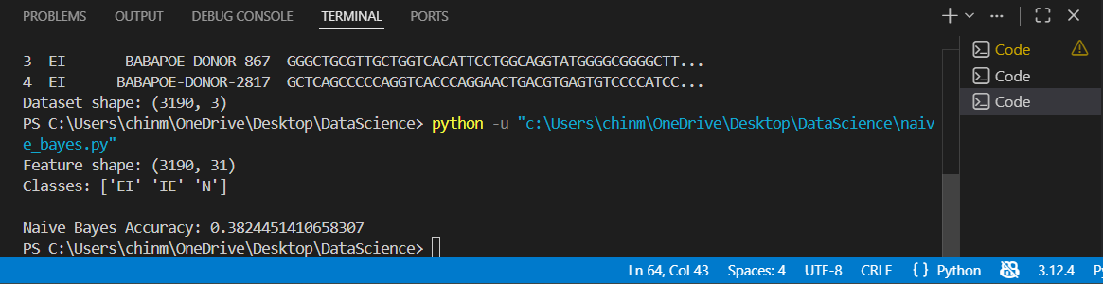

5. RANDOM FOREST
CODE:
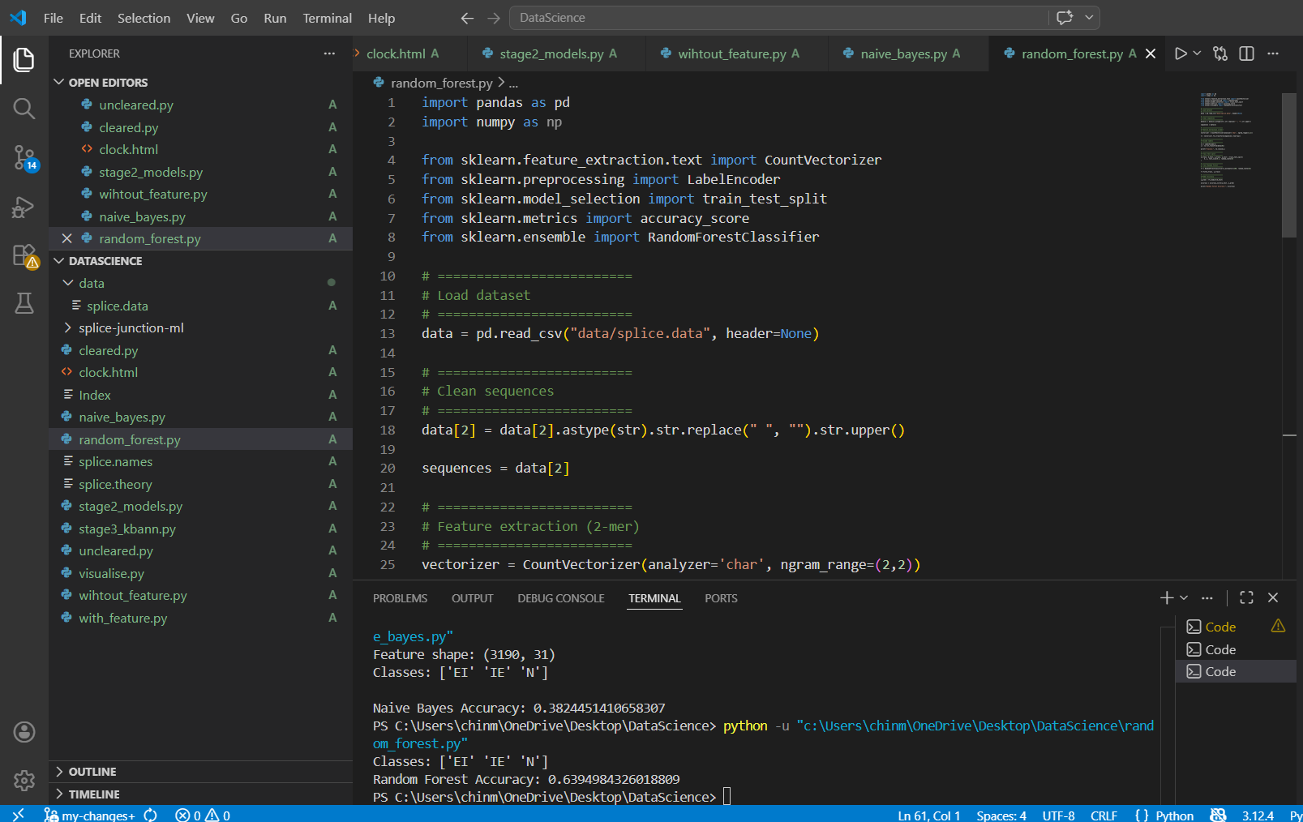
OUTPUT:
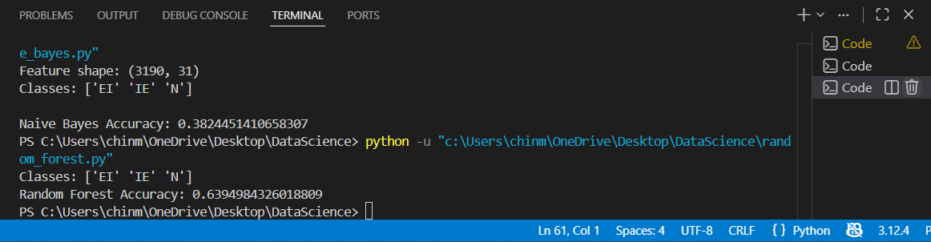

COMPARISION BETWEEN CNN AND KBANN
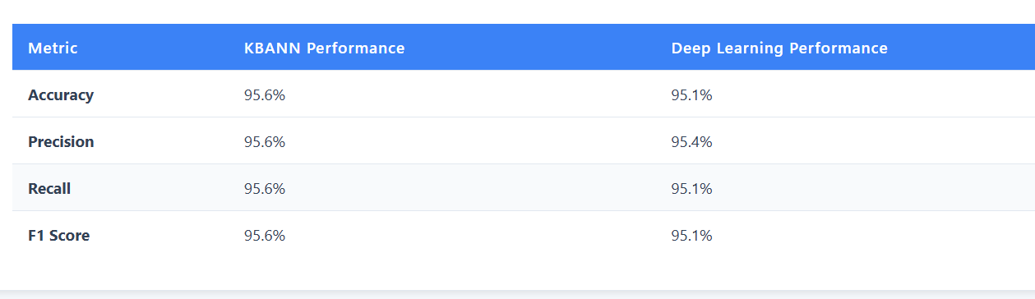

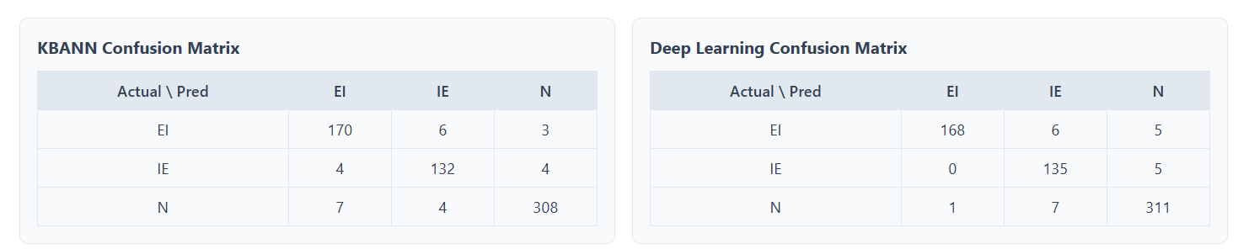

PREDICTION RESULT OF MODEL (KBANN AND CNN)

